**2020 Investment Institute Co-Chairs**

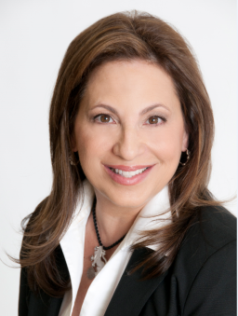**Suzanne Grant (Delaware)** is an accomplished business woman and philanthropist. Suzanne is National Campaign Chair of the Jewish Federations of North America. She is a member of the Board of Trustees of the Jewish Federation of Delaware where she is also a past President.Suzanne currently serves as the Chair of the Delaware Retirement System Board of Trustees, as well as a member of the Investment Committee. She is on the Investment Committee of the Jewish Federations of North America as well as Chair of the Jewish Federation of Delaware Community Endowment Fund Investment Committee. She is a member of the Board of National Women’s Philanthropy where she is the immediate past Vice Chair for Campaign. Suzanne is also a member of the Board of Governors of Hillel International. She graduated from Brandeis University with a degree in Economics and The Wharton School with an MBA in Finance. She spent 20 years working with various Wall Street firms in Sales & Trading as well as Research and Due Diligence of Investment Managers.

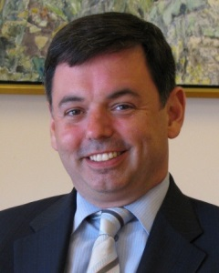**John Hoover (New York)** serves as Senior Vice President and Chief Financial Officer of The Andrea and Charles Bronfman Philanthropies and is a member of the Executive Committee. With foundations in Montreal, Jerusalem and New York, ACBP operates and supports programs in Canada, Israel and the United States. The foundations’ missions are to strengthen the unity of the Jewish people, to improve the quality of life in Israel and to promote Canadian heritage. The foundation operates in a framework of continual innovation and risk management with an emphasis on quality, value creation and sustainability. John is also the Chief Executive Officer of Chasbro Investments, an international single family office. Services of the family office include investment administration, cash and liquidity management, tax and estate planning, partnership and trustee stewardship, risk management, as well as providing support for private art collections, transportation services and real estate. He has founded foundations, public charities, technology firms and financial service firms. He is a Founding Board Director of 21/64 Inc. and is the member of several other Boards. Prior to joining ACBP and Chasbro, he was the Senior Vice President of the Jewish Communal Fund, one of the nation’s largest public foundations with over $1 billion in assets. He continues to be an advisor to several service organizations, businesses and families. John has a Master in Business Administration from Farleigh Dickenson University and a Bachelor of Science in Accounting and Economics from the State University of New York.

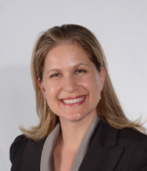**Zoya Raynes** (New York) is the current Board President of the Jewish Communal Fund (JCF). With over $2 billion in charitable assets, JCF is the largest Jewish donor advised fund. She is very active in the nonprofit and philanthropic community, also serving on the Investment Committee of Thanks to Scandanavia, and is a board member of the Jewish Community Relations Council of New York, Jewish Heritage Program, Congregation Shearith Israel (the Spanish and Portuguese Synagogue), and UJA NY’s Investment Management Division. In her professional capacity, Zoya has worked on Wall Street for over 20 years. She is a Managing Director on the Senior Relationship Management team at Bank of America, a global team responsible for enhancing and driving relationships between Bank of America and key institutional investor clients. She was born in Kiev and immigrated to the U.S. in 1979.

**Phyllis Tabachnick (Chicago)** is a Managing Director and Financial Advisor with the Chicago-based Tabachnick Oskin Group at J.P. Morgan Securities. Philanthropically, she has been involved in the Jewish and greater communities ever since she moved to Chicago as a student at Northwestern University. She is currently a member of the Board of Trustees of the Jewish Federation of Metropolitan Chicago, the JCC Association national board, the JCC Chicago board, and the Northwestern University Hillel board. Phyllis serves on the Investment Committees of the Chicago Federation and the Reform Pension Board and is the immediate past chair of the JFNA Investment Institute. She regularly speaks to board members and students of all ages about fundraising and development (presentation titled “Fundraising is not an F Word), leadership, and investment management.

**2020 Investment Institute Advisory Committee**

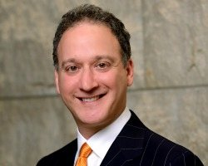**David Brief (Los Angeles)** is a Senior Managing Director at Angeles Investment Advisors. David was the CIO at the Jewish United Fund of Metropolitan Chicago's investment office. Prior to joining the Jewish Federation in 2002, David spent eleven years as an investment consultant for CRA RogersCasey, Ennis Knupp + Associates, and Ibbotson Associates. He also served as Director of Research for the former two firms. Throughout his career, David has authored numerous research papers and has been a frequent speaker at industry conferences on a wide range of investment topics. He received a B.A. in economics from Cornell University, an M.B.A. with honors from the University of Chicago, and also holds the Chartered Financial Analyst designation.

**[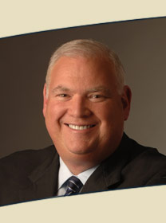](http://www.google.com/url?sa=i&rct=j&q=&esrc=s&source=images&cd=&ved=2ahUKEwiRiOfI29_jAhUj2FkKHfljB8gQjRx6BAgBEAQ&url=http://www.twincapital.com/people/investments.html&psig=AOvVaw3Z7W_GJgGtMnBfM1a69NHj&ust=1564681665006433)Geoff Gerber (Pittsburgh)**,Founder, TWIN Capital Management.

Geoff is the Founder of TWIN Capital Management and serves as the President and Chief Investment Officer overseeing the investment process and general management of the firm. Recognized as a specialist in institutional quantitative investment management, he is often quoted in the financial press and his opinions are often sought by his peers in the industry. Geoff is also a faculty member for the Aresty Institutes Wharton Executive Education Program on Investment Strategies and Portfolio Management. He has served as Chair of the Burroughs Welcome Foundation (BWF) Investment Committee. He also has served as Chair of the Jewish Federation of Greater Pittsburgh’s Foundation Investment Committee and is a member of the Jewish Healthcare Foundation Investment Committee. Geoff is a member of the Editorial Advisory Board of the Journal of Investment Consulting and serves on the Investment Advisory Committee of the New York State Teachers Retirement System (NYSTRS).

[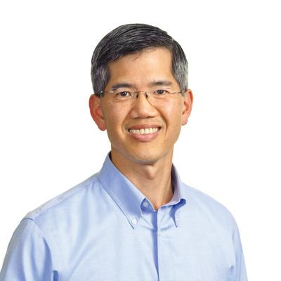](https://www.google.com/url?sa=i&rct=j&q=&esrc=s&source=images&cd=&ved=2ahUKEwje3dXs3t_jAhXNuFkKHY-YDuAQjRx6BAgBEAQ&url=https://www.bizjournals.com/sanfrancisco/feature/cfo-of-the-year/2017/holden-lee-of-jewish-community-federation-and.html&psig=AOvVaw3gNPfUJoefohM46AsJqHJb&ust=1564682545862091)**Holden Lee (San Francisco)** Holden oversees the mechanics and operations of Endowment and Philanthropic Services, as well as the Investment Committee and the Federation's independent investment consultant, Greycourt Advisors. Previously, he was a Managing Director at Cambridge Associates, advising endowments of mission-driven organizations on their investment portfolios and developing impact investing frameworks. Holden's career includes serving as a nonprofit CFO and as a private equity investor. He earned an M.B.A. from the Wharton School and an A.B. in politics from Princeton University.

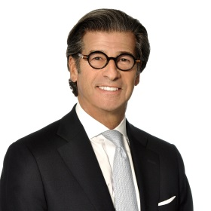**Neil Nisker (Toronto)** is the Co-Founder & Executive Chairman of Our Family Office a newly formed wealth management firm. Prior to that Neil was active with Fiera Capital Corporation, one of Canada’s largest investment managers, from 2006 to 2014, serving as the President of Fiera Private Wealth and as the company’s Executive Vice Chairman and a member of the company’s board of directors and governance committee. Neil served as President of the YMG Private Wealth Management division from 2000 to 2006. Fiera Capital Corporation purchased YMG Capital Management in 2000. From 1997-1999, Neil was the Chairman of Nisker Associates, Strategic Wealth Management, a Canadian registered investment counselling firm. It was acquired by YMG Capital Management in 2000. 1990, Sir John Templeton selected Neil to be one of the three managers of Best Investments International Inc., a global equity mutual fund he owned. Neil held this position until 2000. For more than 25 years, Neil was a driving force behind Brown Baldwin Nisker. Through his diligence the firm grew into one of the premier institutional brokerages in Canada. It was sold to HSBC Securities in 1988. In addition, Co-Chair of the UJA Federation of Greater Toronto, Annual Campaign Co-Chair of the Baycrest Centre for Geriatric Care Campaign, Vice Chair of the Mount Sinai Hospital Foundation and Chair of its Investment Committee, Chairman of The Jewish Foundation of Greater Toronto, Chair of its Investment Committee and Co-chair of the 2011 JFNA Investment Institute in Palm Beach, Florida.

[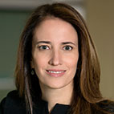](https://www.google.com/url?sa=i&rct=j&q=&esrc=s&source=images&cd=&ved=2ahUKEwiOqo7229_jAhXMtVkKHYXfDLgQjRx6BAgBEAQ&url=https://www.blackrock.com/ca/institutional/en/biographies/suzanne-peck&psig=AOvVaw1qoH7kIk29CtGR_PaPYE0y&ust=1564681757033267)**Suzanne Peck (New York),** Head of Foundations and Endowments Business. Suzanne F. Peck, Managing Director, is Head of BlackRock's Endowment and Foundations effort, which provides investment management services and risk advisory solutions to endowments and foundations. Previously, she was a member of BlackRock's US Client Solutions group, which provides complex solutions support for the Firm's largest institutional clients. The team has a wide range of investment experience across fixed income, equity, alternatives, and specialized investment strategies. Prior to joining the firm in 2013, Ms. Peck spent 18 years with Goldman Sachs. Most recently, she was part of the Investment Management Division, where she served in a number of roles including Portfolio Manager and member of the Investment Committee of Institutional Client Solutions. She also led a team that built an outsourced CIO offering for endowments and foundations. Previously, Ms. Peck spent nine years in the Investment Banking Division in the Real Estate and Consumer/Retail groups, and four years in Fixed Income Portfolio Management. Ms. Peck serves on the Investment Committees and Boards of UJA-Federation of NY and the Jewish Communal Fund. She also serves on the Board of Trustees of the New-York Historical Society. Ms. Peck earned a BA, summa cum laude, in history from Columbia College, MA in economics from New York University and MBA from Columbia Business School.

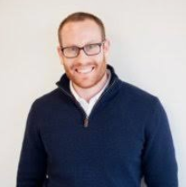

**Dan Rueven** oversees the family business operations of Kinneret Group, a private investment firm. Mr. Rueven has a background in quantitative trading and investments, as well as tech entrepreneurship. He proudly serves on the boards of national and New York-area nonprofits, including The Jewish Funders Network and Slingshot. He is also the treasurer of his condominium building in NYC. Both professionally and personally, he enjoys advising companies, foundations, and individuals on aspects of investments and strategy. Mr. Rueven attended Brandeis University, where he graduated with dual degrees in International and Global Studies, and History, with a concentration in Business.

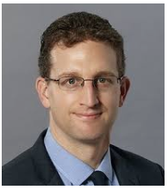**Scott Sandler (Los Angeles)** is a Senior Vice President and Investment Counselor for Capital Group Private Client Services. Scott works directly with high net worth individuals and families to create customized plans for protecting and growing their wealth, often across multiple generations. He also helps nonprofit foundations and endowments to pursue their long-term financial objectives through effective planning and investment management. Before joining our organization, Scott worked as an associate director for ICG Advisors, providing investment consulting services for wealthy families, foundations and endowments. Prior to that, he was a vice president at Zenith National Insurance Corp., a subsidiary of Fairfax Financial Holdings. Scott holds an MBA in finance from Columbia Business School, an MS in advertising from Syracuse University’s S.I. Newhouse School of Public Communications, and a BA in political science from the University of Michigan. Scott is active with the Jewish Federation of Greater Los Angeles, The Milken Institute and Brentwood School.

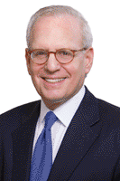**Jeff Stern (New York)** Managing Partner Mr. Stern has more than 35 years of experience in the financial services industry. Prior to founding Forum Capital Partners in 2001, Mr. Stern spent 24 years at CIBC Oppenheimer and its predecessor firm, holding numerous executive and sales positions - the latest being Managing Director and Head of the Private Equity Group. He was responsible for originating, structuring, marketing and overseeing CIBC Oppenheimer's private equity investments on behalf of itself and its clients worldwide. He served on the investment committees of the Brazil Private Equity Fund and The India Private Equity Fund, Genesis Partners and CIBC Oppenheimer Private Equity Partners. Mr. Stern joined Oppenheimer in 1976 and was Director of Investment Management Services, National Retail Sales Manager, Director of Financial Services, and as a member of the firm's Management Committee. Prior to joining Oppenheimer, Mr. Stern worked for both A.G. Becker and Merrill Lynch. Mr. Stern is a member of the Council on Foreign Relations and serves on the boards of directors and investment committees of several philanthropic organizations, including as committee chair at UJA-Federation of New York and United Jewish Communities. An honors graduate of Yale University, Mr. Stern is chair of the international board of the Institute for National Strategic Studies at Tel Aviv University, is a trustee of the Washington Institute for Near East Policy and serves on the President's Council of Westchester Community College.

[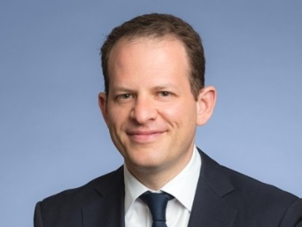](https://www.google.com/url?sa=i&rct=j&q=&esrc=s&source=images&cd=&ved=2ahUKEwipwbiS3t_jAhXLjFkKHRUpDLMQjRx6BAgBEAQ&url=https://www.wynnchurch.com/team/teplitsky-michael&psig=AOvVaw2a0T0T4NYn7snTuUSYu2AH&ust=1564682355921161)**Mike Teplitsky (Chicago)** is a member of the Board of Trustees of the Jewish Federations of North America (JFNA) and served as Chair of JFNA's National Young Leadership Cabinet. Michael is an active leader of The Jewish United Fund of Metropolitan Chicago (JUF) where he served as campaign chair for the Young Leadership Division and was a recipient of the JUF's Young Leadership Award. He is a graduate of the Wexner Heritage Program. Professionally, Michael is a Managing Director at Wynnchurch Capital, LLC, a $2.3 billion industrial private equity investment firm that specializes in recapitalizations, growth capital, management buyouts, corporate carve-outs, and restructurings. Prior to Wynnchurch, he was with Lime Rock Management and at UBS Investment Bank in New York. Mr. Teplitsky holds a B.A., with honors, from Northwestern University and an M.B.A. from The Kellogg School of Management, where he completed the Kellogg Board Fellows Program. He is a director of the Chicago Children's Choir, a member of The Economic Club of Chicago, and the founder of Young Professionals in Energy. A native of St. Petersburg, Russia, Michael was a refusenik in the Soviet Union during the 1980s and immigrated to the United States in 1990. He is a member of Beth El Synagogue in Highland Park, Illinois and is a proud father of two daughters.